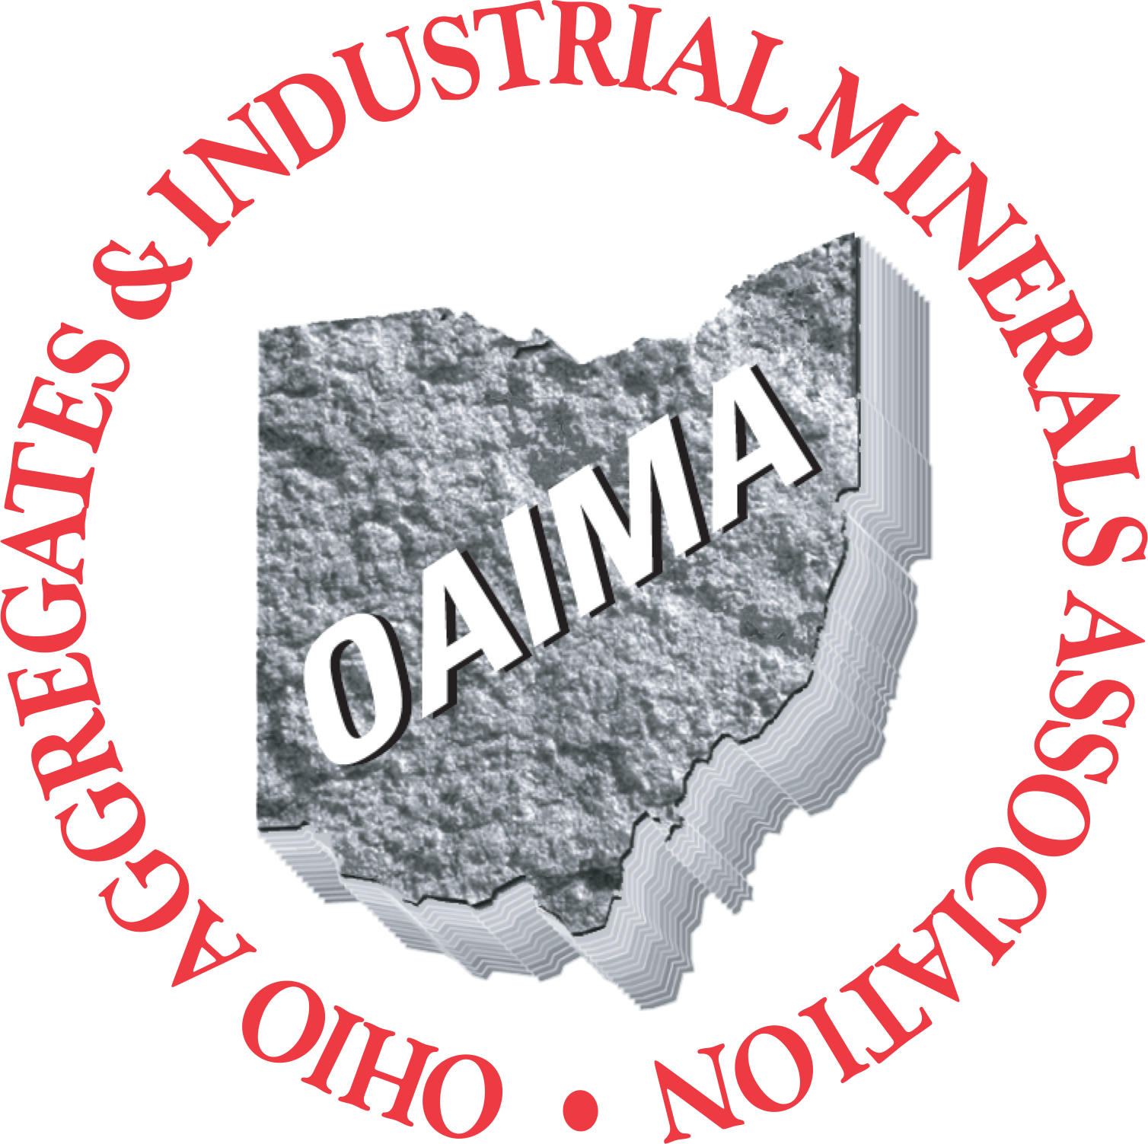
The Ohio Aggregates & Industrial Minerals Association
2024 Emerging Leader Program

The Five Foundational Pillars:
- Networking
- Industry Awareness
- Geographic Awareness
- Leadership Development
- Mentorship/Accountability

Overview of Individual Sessions:
- Each session starts on a Wednesday at noon and ends on Friday at noon. (1/2-day, full day, 1/2-day format).
- Sessions are held in various areas of the state to promote geographic and product awareness.
- Participant travels Tuesday morning arriving at location for informal networking lunch and greeted by program staff and host company where/when appropriate.
- Day 1 (Wed)- Opening session starts at 12 p.m. (noon) with lunch followed by the start of program, adjourning approximately 5:00 p.m. We conclude the day with dinner in a casual setting ideal for networking, relationship building.
- Day 2 (Thurs.) - We begin the next morning with breakfast, followed by continued classroom leadership training and lunch. Following lunch, we travel to an aggregate or industrial minerals facility for a tour and learn about the operation. We conclude the tour with a debrief and recap of the day. We return to the hotel following the tour. We conclude the day with a dinner that will include a guest speaker when possible.
- Day 3 (Friday.)- The closing session will provide a morning wrap-up with training/speaker and conclude with a box lunch. Travel home that afternoon

Each Session includes the following components:
1. Technical (facility tour/subject matter expert), safety discussion at the facility.
2. Self-development (individual, team, organization).
3. Networking (with both participants and local industry leadership).
4. Political (introduction to local elected officials as they serve as session guest speakers).

Session Highlights:
- Thorough debrief after each session - What did we learn? Workplace applications? Adult learning principles applied as opposed to traditional “school.”
- Greg Coker provides one-on-one coaching during interim (between each session). If the attendee should need more coaching on a specific subject, Greg Coker will be available to provide further assistance throughout the duration of the program.
- Reading material between each session. Each participant will be provided reading material recommendations and encouraged to do some homework between each session which will assist in better understanding the previous session and/or help better understand what will take place during the next session.
- During the first session we introduce the importance of “Mentoring” within one’s organization with the expectation that each participant will select a mentor within her/his organization before Session Two. A training module will be provided for both the participant and the Mentor (between sessions one-two) with continuous support from Greg Coker/OAIMA staff throughout the process.

Application Process: A Sponsor and Candidate Application Required for Each Nominee
Participant/Company Investment:
- The tuition for the 2024 Ohio Aggregates & Industrial Minerals Association Emerging Leader Program is a suggested $3,500 per individual.
- Minimum attendance is 15. Maximum attendance is 20.
- The tuition does not include lodging and/or transportation to/from program sessions.
- Investment covers the cost of the meeting locations in the hotel settings, food and beverages, any outside speakers, transportation for the group at each location, etc.

Program Overview (as of 1-22-24)

Session One: Leadership & Management
Location: TBD
Host Member: TBD
Dates: Wednesday May 22 and Thursday May 23 and Friday May 24

Session Two: Finance / Mini MBA
Location: TBD
Host Member: TBD
Dates: Wednesday July 10, Thursday July 11 and Friday, July 12

Session Three: Organizational Dynamics & Team Effectiveness
Location: TBD
Host Member: TBD
Dates: Wednesday August 21, Thursday August 22, and Friday August 23

Session Four: Continue Strategic Planning, Work/Life Balance, Negotiation, Customer Service
Location: TBD
Host Member: TBD
Dates: Wednesday October 16, Thursday October 17, and Friday October 18

2023 OAIMA Emerging Leaders Program Graduates at the OAIMA Annual Meeting.
Session Five: Reunion & Graduation/OAIMA Annual Meeting Wednesday, November 13 to Friday November 15, 2024

Appendix
Workshop Topics/Training Outcomes (covered within the four sessions)

- Building Cathedrals: The Power of Purpose. Module Outcome: To see one’s organization’s higher purpose. The “WHY” that author/speaker/consultant Simon Sinek highlights. I use a “Cathedral” as a personal/organizational expression of purpose.
- Managing the Business; Leading your People. Module Outcome: Realize the difference between management and leadership and the importance of and need for both.
- The Appreciation of Differences (Related to Communication Style). Module Outcome: To realize we approach life and work from four basic perspectives (Driver, Analytical, Expressive, Amiable) and should understand, appreciate and utilize each approach. I’m also certified in the Myers Briggs Type Indicator (MBTI). Participants could take this instrument prior to workshop and I could share results during this session. MBTI is similar to the Driver, Analytical, Expressive, Amiable Model but more in-depth and considered the Gold Standard of personality profiles. If we decide to go with MBTI, this would replace the Driver, Analytical, Expressive, Amiable Model. Bottom line, the time needed would be roughly the same.
- Emotional Intelligence (EQ in addition to IQ). Module Outcome: Emotional Intelligence (EQ) is a relatively new term. We introduce what EQ is, why it’s important and the key components. Just like it’s not Management OR Leadership but rather Management AND leadership, we emphasize its not IQ OR EQ but rather IQ AND EQ.
- Coaching/Mentoring. Module Outcome: Most think of Coaching as a sports coach. That’s more directing versus coaching. Also, more and more employees (especially newer ones) are asking for a personal coach/mentor. We explain what a coach is and what it’s not and provide a coaching model.
- Team Effectiveness. Module Outcome: Most teams are not reaching peak performance (Hence the book, The Five Dysfunctions of a Team). We cover the characteristics of effective teams, the steps of team growth (Form-Storm-Norm-Perform) and specific strategies to build highly functioning teams.
- Change Management. Module Outcome: The only constant is change. I cover the seven dynamics of change and their impact on employees while presenting strategies for implementing needed changes.
- Customer Satisfaction: Module Outcome: Very often, we make customer service harder than it has to be. We simplify by outlining the four basic things customer’s want, the art of recovery when we drop the ball, how customers rate us, cycles of service and key moments of truth that are most important for the customer.
- Problem-Solving/Project Management. Module Outcome: The topic itself is a bit intimidating. I share a simple problem-solving tool (GBASS: Goals, Barriers, Alternatives, Selection, Sequence) outlining how it can be used from the grocery store floor to more formal planning sessions.
- Performance Management (The Appraisal Process) Module Outcome: Get rid of “Evaluations” and replace with “Real Conversations” regarding performance and how to get even better. Big emphasis on Coaching.
- Handling difficult conversations: Getting the “wrong people off the bus” with dignity and self-esteem in place. Module Outcome: Give participants specific strategies on how to have that difficult conversation when things just don’t work out with an employee.
- Employee Orientation. Module Outcome: The importance of and specific strategies to getting employees productive once we hire them versus a “Glad you’re here, fill out all this paperwork, you’ll start tomorrow.” Organizations with a strong onboarding process improve new hire retention by 82% and productivity by productivity by more than 70%.
- Negotiation. Module Outcome: While almost 100% of managers say negotiation is a critical skill, less than 10% report ever having training on the topic. We discuss “Above the Line” (the numbers) and “Below the Line” (the psychology/human dynamics” aspects of “Win-Win” negotiations.
- Culture. Module Outcome: Participants will understand how they are a HUGE part of the overall organizational culture, and they must “own” the culture of their operations. Numerous surveys report culture is one of the main reasons’ employees stay and one of the main reasons they leave. Culture is tied to more “human dynamics” versus “technical expertise.”
- Taking Care of You: Stress Management. Module Outcome: Everyone’s at their wits end. We can’t take care of others if we’re not taking care of ourselves. We provide the seven characteristics of people who manage stress.

