Donna Davis
Science/ Gr. 8
How does your shadow grow?
Abstract
On any sunny day a shadow is cast by any object that blocks the sun. It is called a gnomon. Objects that are stationary like bridges, mailboxes, buildings, and statues are common gnomons. The shadows from these gnomon that change throughout the day have long been used to understand connections of the movement of the earth about the sun.
By making a gnomon (sundial) and placing it in a consistent place (on sunny days), students will be able to observe the length of the shadow at the same time of day. When students learn through inquiry, they make quantitative and qualitative observations, analyze data, ask new questions, make inferences, draw conclusions and investigate new questions, they will be able to infer the movement of the earth. This is a year long project that allows students to gradually see the changes in th Earths movement in relation to the sun as a reference point.
Grade
This inquiry activity will be used with grade eight general education science classes or it in general earth classes.
Resource Type

This is designed to be an outdoor / indoor lab that will be on going throughout the school year to record shadow lengths ( a sample form each season).
.
Subject
Earth Science/ Astronomy/ Astrophysics

National Science Standards

Content Standard A: Science as Inquiry
As a result of activities in grades 5-8, all students should develop
- Abilities necessary to do scientific inquiry
- Understandings about scientific inquiry

Content Standard E: Science and Technology
As a result of activities in grades 5-8, all students should develop understanding of
- Abilities of technological design
- Understandings about science and technology
- Unintended consequences. Some consequences can be predicted, others cannot.
Content Standard F: Earth Science
As a result of activities in grades 5-8, all students should develop understanding of
- Earth in the solar system

Content Standard G: History and Nature of Science
As a result of activities in grades 5-8, all students should develop understanding of
- Nature of science
- Science requires different abilities, depending on such factors as the field of study and type of inquiry. Science is very much a human endeavor, and the work of science relies on basic human qualities, such as reasoning, insight, energy, skill, and creativity—as well as on scientific habits of mind, such as intellectual honesty, tolerance of ambiguity, skepticism, and openness to new ideas.
- Scientists formulate and test their explanations of nature using observation, experiments, and theoretical and mathematical models.
- It is part of scientific inquiry to evaluate the results of scientific investigations, experiments, observations, theoretical models, and the explanations proposed by other scientists. Evaluation includes reviewing the experimental procedures, examining the evidence, identifying faulty reasoning, pointing out statements that go beyond the evidence, and suggesting alternative explanations for the same observations. Although scientists may disagree about explanations of phenomena, about interpretations of data, or about the value of rival theories, they do agree that questioning, response to criticism, and open communication are integral to the process of science. As scientific knowledge evolves, major disagreements are eventually resolved through such interactions between scientists.
(http://www.nap.edu/openbook.php?record_id=10618&page=31)
Ohio Science Standards for Science Content & Inquiry
Benchmark A Grades 5-8: Scientific Inquiry

Explain that there are differing sets of procedures for guiding scientific investigations and procedures are determined by the nature of the investigation, safety considerations and appropriate tools
Benchmark B Grades 5-8: Scientific Inquiry

Analyze and interpret data from scientific investigations using appropriate mathematical skills in order to draw valid conclusions.

Benchmark A Grades 6-8: Benchmark -Scientific Ways of Knowing

Use skills of scientific inquiry processes (e.g., hypothesis, record keeping, description and explanation).

Identify the difference between description (e.g., observation and summary) and explanation (e.g., inference, prediction, significance and importance).

Benchmark A Grades 6- 8: Earth and Space Science

Describe how the positions and motions of the objects in the universe cause predictable and cyclic events.

Describe how objects in the solar system are in regular and predictable motions that explain such phenomena as days, years, seasons, eclipses, tides and moon cycles.

Explain that gravitational force is the dominant force determining motions in the solar system and in particular keeps the planets in orbit around the sun.

Hamilton City Schools Course of Study Objectives
(We follow the state content standards- the course of study is 24 pages long for each academic level taught. There are four levels)
SI – A.1 - Choose the appropriate tools or instruments and use relevant safety procedures to complete scientific investigations.
SI -A.2 – Explain why it is important to examine date objectively and not let bias affect observations.
SI- B.3 - Read, construct and interpret data in various forms produced by self and others in both written and oral forms (e.g., tables, charts, maps, graphs, diagrams and symbols).
SI- B.4 - Apply appropriate math skills to interpret quantitative data (e.g., mean, median and mode
ES – A. 1 – Explain that gravitational force is the dominant force determining motions in the solar system and in particular keeps the planets in orbit around the sun.
ES – A. 2 – Explain that gravitational force is the dominant force determining motions in the solar system and in particular keeps the planets in orbit around the sun.
ST – A. 1 – Examine how science and technology have advanced through the contributions of many different people, cultures and times in history.
ST – A. 2 – Examine how choices regarding the use of technology are influenced by constraints caused by various unavoidable factors (e.g., geographic location, limited resourced, social, political and economic considerations).
SI – A. 1 - Choose the appropriate tools or instruments and use relevant safety procedures to complete scientific investigations.
SI – B. 3 - Read, construct and interpret data in various forms produced by self and others in both written and oral forms (e.g., tables, charts, maps, graphs, diagrams and symbols).
SK – A.1 - Identify the differences between description (e.g., observation and summary) and explanation (.e.g., inference, prediction, significance and importance).

Objective(s)
Students will use inquiry to test, design and build a functional reusable gnomon to measure shadows using problem solving skills and constraints as apply in a real world to new situations.

Students will develop critical thinking skills to problem solve.

Students will gather and interpret quantitative data in various forms (length in cm, suns declination and coordinal direction of the sun, shadow and time in minutes) to create meaningful graphs.

Students will show confidence and success in the interpretation of quantitative data (measurements of shadow length changes through the seasons).

Students will show evidence of understanding of the reasons the shadow changes as a result of the movement of the earth about the sun.

Students will construct graphs and tables to use to visualize the validity of the data collected.

Students will relate and synthesize data collected and research to find the tilt of the earth is responsible mostly for seasonal change.

Students will apply knowledge of earth’s tilt, shadow measurements and seasonal change to form new questions and new investigations and research.

Students will gain knowledge of coordinates (N, S, E, W, NE, NW, SE , SW) to better apply direction and points of reference.

Pre-assessment: How does your shadow grow? Name___________________________
1. What is a gnomon?

2 Describe what you have ever noticed about a shadow?

3. What would you use to measure the length of your shadow?

4. Tell what you know about Earth’s movement.

5. When would the shadow be the longest?

6. Is there any change in shadows between the summer and the winter at the same time of the day? If so predict which season would have the longest shadow at noon.

7. Which direction of the sky is the sun in the morning?

8. Which direction of the sky is the sun after 12 noon?

9. Which direction is the sun in the sky at sunset?

10. Does weather have anything to do with shadow?

11. How could knowing where your shadow is facing and the length ever be helpful?

12. How did ancient people use the idea of shadow to help them?

13. Illustrate the position of the earth as it rotates about the sun?

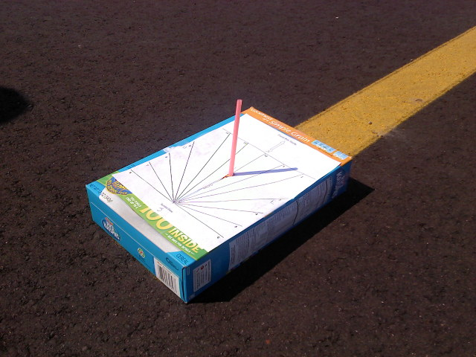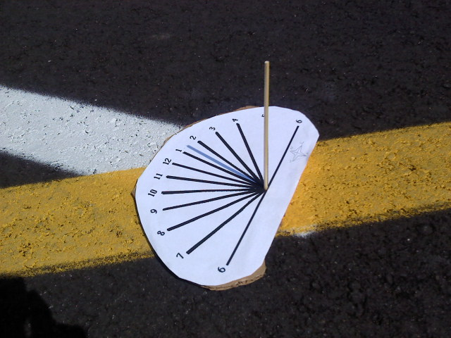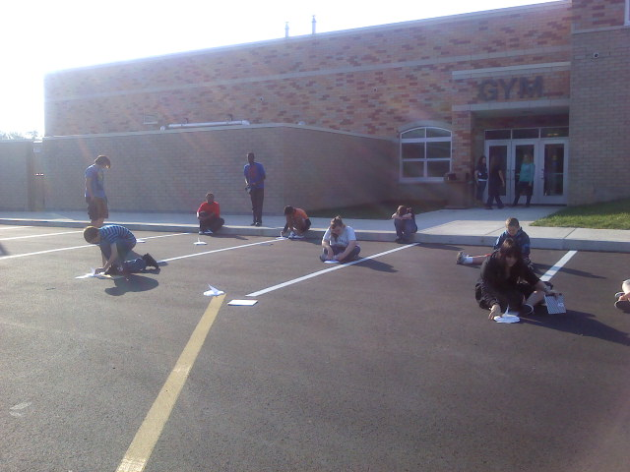
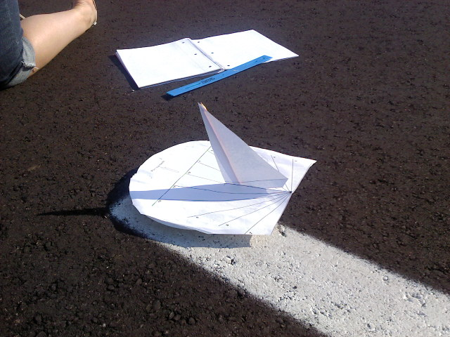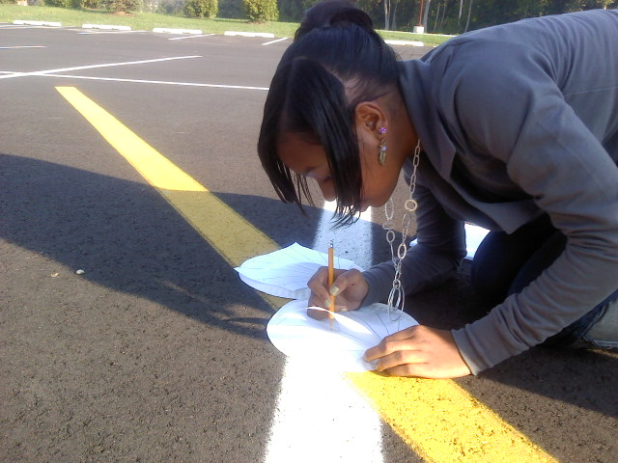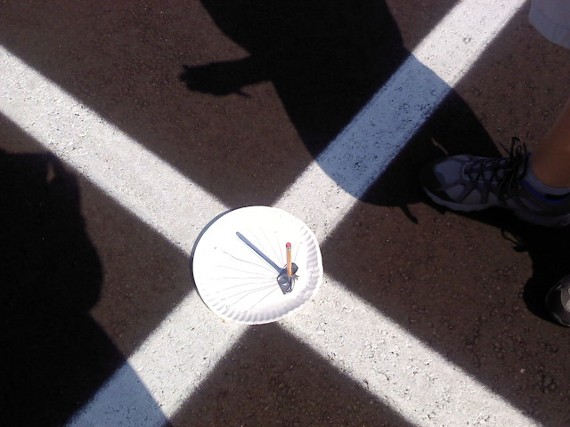
Lesson Plan

Earth’s Position relative to the sun/ How does my shadow grow?
Inquiry lesson
You need sunny days to do this!
Pre - activity
After Pre-test, students will go outside and observe their shadows. And write in their journals what they observe (qualitatively or quantitatively)
Materials
Meter sticks rulers cardboard gnomon template glue scissors directional compasses

protractors watch cell phone (for timing) globe straws paper plates

Experiment
Day One
When students return to the lab tell them that they were just a gnomon! Discuss what a gnomon is and brainstorm how they could make a permanent gnomon. Show students some gnomons or sundials and discuss what casts a shadow.

Homework: Provide students with a template (and accept creative ideas) of what would make a good gnomon to use each day at school. to make a gnomon and cardboard or other paper, scissors, and glue. Have them construct a gnomon and/ or encourage them to use their own creative devices.
Day Two
Students will take their gnomons outside (Be aware of safety issues with traffic etc) and decide where would be a good spot to place their gnomon each time. Discuss as to why that would be important. (Discuss variables of wind and possibilities of shade)

Allow 10 minutes for students to experiment moving their gnomon around.
Return to classroom and discuss problems. Students should record problems with their design and try to eliminate or remedy problems (flimsy- blew away. Flimsy the gnomon part would not stay straight etc..) for example too, maybe they did not know which direction was north.
Students will find that they may have to tweek their design. ( ie the wind etc) After the first day they may be completely lost as to which way to face their gnomon and which way in north south or east or west. That’s when questioning comes in to plan. Student should direct the shadow to the correct time whil eponit the gnomon to the North. (see picture)
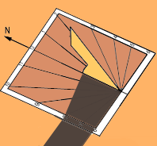

Day Three (take rulers, and compasses outside)
When students are outside, ask students where the sun rises? Do not accept “over there”. Lead them to discover where North South East and West is, in relative to your spot. You may even do this if it is cloudy. But try to get out as much as possible the first weeks of school while it is still “summer”. Take students out to their ‘spot’ discuss why it is important to go to the same spot each time. Help student understand in lining the shadow up with the time. (see handout) By day three students should be getting a handle on how to position their gnomon. (Pointing north with the shadow on the edge of the exact time ( cell phone work great for satellite time ). Students can be given directional compasses to learn how to find directional North.

Day Four
By now students should be putting together a data table, recording shadow lengths and starting to make some inferences about the shadows and the lengths as they are measuring in cm at about the same time of day. ( I go outside at the beginning of each class period as weather permits- for only 5 minutes) Have them write a hypothesis as to what they think will happen to their shadow when autumn comes.

Day Five
Students should have the idea by now as to where to place the sundial (gnomon) and where the sun will be and which direction of the sky it is in at that time. Picture Time: Line students up, facing North, in a straight line (see pics) and take a photo (including their shadow) of each class throughout the day (if applicable). Then you can have comparisons for a side show. The kids love this! They are amazed to see the shadow differences. You can even use these pictures in a slide show or on a quiz for questioning.

By now you have a schedule figured out and you have students weather watching for ‘shadow’ day! When you have enough data, usually at least five recordings for summer, have students revisit their hypothesis, and record any new thoughts in their science journal. Check data tables for date, time, length and direction of the sun in the sky. Students will not need compasses any more.

After you have at least five – ten readings, begin to have students graph the lengths of their shadows. They will inquire as to why they are different and begin to see inaccuracies in data collection.
Continue with the lesson asking questions:

Why do you think the shadow is changing?

How is the shadow changing?

Predict the changes in winter.

Future days as planned:

Allow students to visit the computer lab or offer extra credit as to who can find out why the shadow is changing.

Make a big deal out of the Autumnal Equinox that day- and if possible measure the shadow that day.
(http://www.timeanddate.com/calendar/september-equinox.html) (article to read)
http://news.nationalgeographic.com/news/2009/09/090922-autumnal-equinox-2009-fall-equinox.html
( video)

As student gather more data, continue to graph and record to update changes. As students realize that the gnomons might be different heights and shadows different lengths have them brainstorm as to how they can solve that problem.

This project goes year long and the connections are endless. The student will guide the teacher in the connections to make as they begin to ask better questions and research to find the answers.
Encourage students to do further research as you apply the use of protractors to measure the angle of the sun.

Allow students to research and come to discover the changes of the angle of the sun in relationship to the tilt of the earth. Provide any resources that may help them.

Post assess as you deem when ready. In past years, I actually used a Student response software(Clickers) quiz, using the actual pictures in the questions as a post quiz, integrating inferences and observations from the lab activity. The post assessment was given to students who were absent or unable to take the software quiz.
Resource pictures:
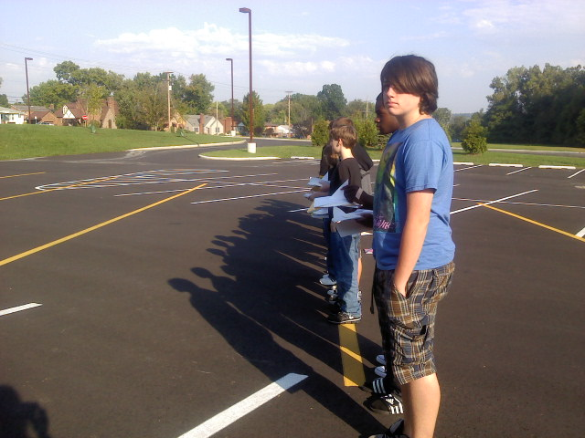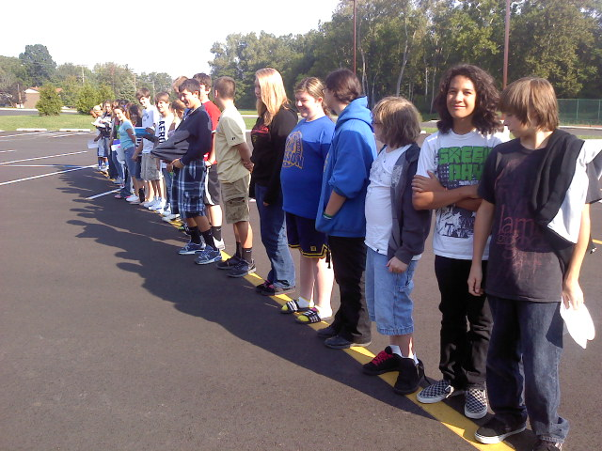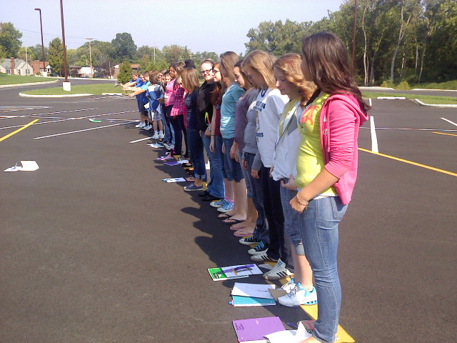

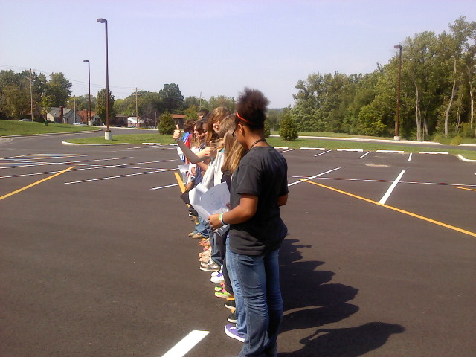

Resources:
http://www.bbc.co.uk/norfolk/kids/summer_activities/make_sundial2.shtml
http://www.sciencekidsathome.com/science_experiments/sundial-1.html
http://www.skyandtelescope.com/letsgo/familyfun/Make_Your_Own_Sundial.html
http://www.nmm.ac.uk/server/show/conMediaFile.5228
http://library.thinkquest.org/C0114964/dial.htm
http://www.sundials.co.uk/projects.htm

Templates:
http://www.nmm.ac.uk/upload/pdf/sundial_template.pdf (students like this one the best)
http://www.bbc.co.uk/norfolk/kids/sundial_gnomon.pdf
http://www.bbc.co.uk/norfolk/kids/sundial_base.pdf
http://www.technologystudent.com/prddes1/dialmod1.html

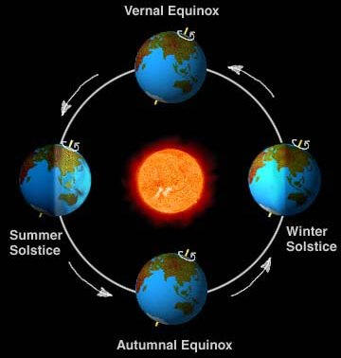

Post-assessment: How does your shadow grow? Name ___________________

1. Where (direction) does the sun rise and set?

2. Give two examples of gnomons?

3. If students measured the shadow of a building all day, when (time of the day) will the shadows be the shortest?

4. How does the shadow length differ according to seasons?

5. Describe one quantitative observation and one qualitative observation.

6. Why would ancient people have used gnomons?

7. What were some constraints or problems you encountered with measuring your shadow lengths?

8. Describe the angle of the earth.

9. Illustrate the position of the earth as it revolves about the sun for each season.

10. What was the independent and dependent variable in this activity?

11. What would you do differently next time?

12. What challenges did you face when you created a graph to show your results?

13. What did you learn that you did not know prior to doing this activity?

